Python Data Types & List:-

- Python lists are created using comma-separated values inside square brackets.
- Python is a dynamically typed (not strongly typed) language, unlike Java or C++.
- You don’t need to declare data types explicitly.
- The data type is automatically inferred from the value.
Example:
x = 3→ integer
y = "google" → string
You can check a variable’s data type using the type() function.
Python is slower than Java or C++ when you use normal loops
Yet, Python is the most popular language in data science & analytics
This seems confusing because data work involves huge datasets (GBs/TBs)

Why Python is still ideal for data Simplicity:
- Easy for both technical and non-technical (business) users
- Data science is a mix of business thinking + technology
- Speed problem is solved using NumPy
- NumPy is written in C (very fast)
- It avoids slow Python loops using vectorization
- Uses parallel processing where possible

So:
Python + NumPy = Simple + Fast
Example 1: Python list (slow way)
Task: Multiply every number by 2
votes = [775, 787, 848, 854]
result = []
for v in votes:
result.append(v * 2)
print(result)

🔴 Problem:
Loop runs one value at a time
Execution is sequential
Slower for large data
Example 2: NumPy array (fast way)

import numpy as np
votes = np.array([775, 787, 848, 854])
votes * 2
🟢 Output:
array([1550, 1574, 1696, 1708])
Why this is powerful:
No loop written by you
Operation happens internally in C
Uses vectorization

Can run multiple calculations in parallel
1.Creating a 2D NumPy Array
- A 2D NumPy array is like a matrix
- It is created by wrapping multiple 1D lists inside another list
Simple examples:
import numpy as np
arr_2d = np.array([
[1, 2, 3],
[4, 5, 6]
])
This means:
2 rows
3 columns

2.. Checking Dimensions and Shape
arr_2d.ndim
➡️ Output: 2
(2 dimensions: rows and columns)
arr_2d.shape
➡️ Output: (2, 3)
(rows, columns)

3. NumPy Arrays Are Homogeneous (Single Data Type)
Unlike Python lists, NumPy arrays can store only ONE data type.

Python List (flexible)
lst = [2, 2.3, "Python", True]
NumPy Array (structured)
np.array([2, 2.3, "Python", True])

➡️ Output:
array(['2', '2.3', 'Python', 'True'])
Everything got converted to string

4. Why Did NumPy Convert Everything to String?
- NumPy must keep one data type
- Python tries to avoid errors
Since:
int → string ✅
float → string ✅
boolean → string ✅
NumPy chose string as the common type

5. Why This Restriction Is Important
NumPy is built for numerical operations like:
array * 2
array / 10
These operations:
ONLY make sense on numeric data
Would break if data types were mixed

INDEXING & SLICING
1. Indexing (Accessing ONE element)
Indexing starts at 0
Same as C / Java / JavaScript
Example
votes = np.array([88, 77, 66, 166, 286, 256, 402])
votes[3]
➡️ Output:
166
Index positions: 0 1 2 3 (4th element → index 3)
2. Slicing (Accessing a RANGE of elements)
Syntax:
array[start : end]
⚠️ Very important rule
Start index → included
End index → NOT included
Example 1
votes[1:4]
➡️ Output:
[77, 66, 166 ]
Starts at index 1
Stops before index 4

3.Negative Indexing (Python-specific feature)
Python allows indexing from the end.
Example
votes[-1]
➡️ Output:
402
Meaning:
-1 → last element
-2 → second last
-3 → third last

NumPy Boolean Masking
Masking means using a True/False array to choose which elements to keep.
votes = np.array([50, 120, 260, 400])
votes < 300
Result (boolean mask):
[ True, True, True, False ]
Using the Mask to Select Values
votes[votes < 300]
Output:
[50, 120, 260]
👉 Elements are kept where the mask is True.

Changing the Threshold Changes the Mask
votes < 100
# [ True, False, False, False ]
votes < 300
# [ True, True, True, False ]
Masking vs Slicing
Slicing → continuous range
votes[1:3] # [120, 260]
Masking → arbitrary positions
votes[votes < 300] # [50, 120, 260]

1️⃣ Sorting in NumPy
🔹 np.sort()
- Sorts values
- Returns a new sorted array
- Original array is unchanged
import numpy as np
votes = np.array([120, 88, 340, 200])
np.sort(votes)
Output
[ 88 120 200 340 ]

🔹 np.argsort()
- Returns indexes that would sort the array
- Does NOT return sorted values
Syntax: np.argsort(votes)
Output
[1 0 3 2]
Meaning
- Smallest value 88 is at index 1
- Next 120 at index 0
- Then 200 at index 3
- Then 340 at index 2

2️⃣ Aggregation Functions (Summarization)
Aggregation = summarizing data into a single value
Common Functions
- sum()
- mean()
- min()
- max()
Syntax (both are valid)
np.mean(arr)
arr.mean()

Example (2D Restaurant Data)
data = np.array([
[100, 500], # votes, cost
[200, 700],
[50, 300]
])
- Total votes
data[:, 0].sum()
- Average cost
data[:, 1].mean()
📌 : → all rows
📌 0 / 1 → column index

3️⃣ Axis (🔥 VERY IMPORTANT 🔥)
Axis tells NumPy the direction of operation
Axis | Meaning | Direction
axis=0 | Column-wise | ⬇ Down
axis=1 | Row-wise | ➡ Side
Example
np.sum(data, axis=0) # column-wise sum
np.sum(data, axis=1) # row-wise sum

4️⃣ Why We Move from NumPy → Pandas
❌ Limitation of NumPy
- NumPy arrays are homogeneous
- All values must be same data type
Real-world data is heterogeneous
Name | Salary | Department
Alice | 50000 | HR
Bob | 60000 | IT
❌ In NumPy:
- Salary becomes string
- You cannot do:
  - sum
  - mean
  - arithmetic operations

✅ Why Pandas Exists
Pandas was created to:
- Handle real-world tabular data
- Allow different data types per column
- Still keep NumPy speed & vectorization
📌 Pandas works mainly with 2D data (Excel-like tables)

5️⃣ Pandas Data Structures (Hierarchy)
1️⃣ DataFrame
- Table (rows + columns)
- Like an Excel sheet
2️⃣ Series
- Single column
- Each column in a DataFrame is a Series
DataFrame
├── Series (Column 1)
├── Series (Column 2)
└── Series (Column 3)

6️⃣ Loading & Inspecting Data
import pandas as pd

df = pd.read_csv("data.csv")
df.info()
Shows
- Rows & columns
- Column names
- Data types
- Missing values

7️⃣ Pandas Is Built on NumPy
df.values
- Returns NumPy array
- Pandas internally uses NumPy → fast performance

8️⃣ Vectorization (🔥 VERY IMPORTANT 🔥)
- Performing operations on an entire array at once
- No loops needed

🔑 Final Key Takeaways (Must Remember)
- NumPy → fast but homogeneous
- Pandas → fast + heterogeneous
- DataFrame = table
- Series = column
- Vectorization = no loops
We learned three major things: Concat, Sorting, and Merge (Joins) in Pandas.

First, Concat is used to combine DataFrames without checking any column values. It simply joins data based on index.

For example:
pd.concat([df1, df2])b
It just stacks them. It does not check if product IDs match. To fix index duplication,
we use:
pd.concat([df1, df2], ignore_index=True)

So remember: Concat = blind combining (index-based).
Second, we learned about Sorting using:
df.sort_values(by='votes')
This sorts in ascending order by default.
For descending:
df.sort_values(by='votes', ascending=False)
For multiple columns:
df.sort_values(by=['votes', 'rating'])
This means:
First sort by votes
If votes are same, then sort by rating
If you want different directions:
df.sort_values(by=['votes','rating'], ascending=[True, False])
Meaning:
votes → ascending
rating → descending
Important: The second column sorting works only when the first column values are equal.
Third and most important, we learned about Merge (Join).
Merge combines tables based on matching column values.Example:
Orders table:
product_id user
P1 A
P2 B
P3 C
Products table:
product_id price
P1 100
P2 200
P4 300
Merge using:
pd.merge(orders, products, on='product_id')
This is an Inner Join (default).
Result:
product_id user price
P1 A 100
P2 B 200
P3 and P4 are removed because they don’t match.
Other join types:
how='left' → keeps all rows from left table
how='right' → keeps all rows from right table
how='outer' → keeps all rows from both tables
Example left join:
pd.merge(orders, products, on='product_id', how='left')
P3 will appear with price = NULL.
Final Key Points
Concat → Combines by index (no matching logic)
Sorting → Organizes data by column values
Merge → Combines data based on matching column values (like SQL join)
Inner join keeps only matching rows
Left/right/outer control which unmatched rows are kept

loc vs iloc in Pandas:
Both are used to select data from a DataFrame, but they work differently.
✅ 1️⃣ loc → Label-Based Selection
loc selects data using row labels and column names.

Example:
df.loc[2, 'name']
Meaning:
Row label = 2
Column name = 'name'
So it looks for actual labels, not position.
Example DataFrame:
index name marks
0 A 80
1 B 90
2 C 70
df.loc[1]
Output → Row where index label = 1 (student B)
Multiple rows:
df.loc[0:2]
⚠ Important: In loc, the ending index is INCLUDED.

2️⃣ iloc → Position-Based Selection
iloc selects data using integer positions (like array indexing).
Example:
df.iloc[1]
Meaning:
Give me row at position 1
(Second row)
Select specific cell:
df.iloc[2, 1]
Meaning:
Row at position 2
Column at position 1
Multiple rows:
df.iloc[0:2]
Important: In iloc, the ending index is EXCLUDED (like Python slicing).
So this returns row positions 0 and 1 only.
- loc → label
- iloc → integer location

Lambda, Apply, Vectorization, GroupBy & Reshaping in Pandas
🔹 1️⃣ Lambda (Inline) Functions
Lambda = Single-line function
Syntax:
lambda inputs: expression
Example:
Traditional function:
def add(x, y):
return x + y
Lambda version:
add = lambda x, y: x + y
✔ No return keyword
✔ Used for small, quick logic
✔ Often used inside .apply()

🔹 2️⃣ .apply() in Pandas
Works row by row
Similar to a loop (sequential execution)
Slower than vectorized operations
Use .apply() when:
Logic is complex
Multiple conditions exist
Example:
df["new_col"] = df["price"].apply(lambda x: x * 2)

🔹 3️⃣ Vectorization vs .apply()
Vectorized. .apply()
✅ Faster slower
Internally optimized Loop-like
Simple syntax More flexible
Best for simple logic Best for complex logic
🎯 Rule:
Always prefer vectorized operations first.
Use .apply() only when vectorization is not possible.

🔹 4️⃣ Data Cleaning Mentions
Regex
Used for pattern matching (e.g., removing $ from price).
astype()
Used to convert cleaned columns into numeric:
df["price"] = df["price"].astype(float)
If data has:
Nulls
Multiple symbols
Mixed formats
👉 Then .apply() might be required.
🔥 GroupBy Concepts

🔹 5️⃣ GroupBy – 3 Step Process
Split – Divide data into groups
Apply – Perform aggregation
Combine – Return summarized result
Example:
df.groupby("category")["rating"].mean()
👉 Get average rating per category.

6️⃣ GroupBy on Multiple Columns
df.groupby(["category", "product_name"])["rating_count"].agg(["min", "max"])

Important:
Multiple grouping columns → use list []
Multiple aggregations → use .agg()

🔹 7️⃣ Multi-Index
When grouping by multiple columns, Pandas creates a Multi-Level Index.
⚠ Harder to filter
⚠ Harder to use .loc

8️⃣ Filtering After GroupBy
Common pattern in real-world:
result = df.groupby("category")["rating"].mean().reset_index()
result[result["rating"] > 4]
Business Flow:
Group → Aggregate → Filter → Sort
🔥 Data Reshaping (Very Important)

9️⃣ Melt (Wide ➜ Long)
Used when multiple columns should become one column.
Before (Wide):
| product_id | actual_price | discounted_price |
After (Long):
| product_id | price_type | price |
Syntax:
pd.melt(
df,
id_vars=["product_id"],
value_vars=["actual_price", "discounted_price"],
var_name="price_type",
value_name="price"
)
Key Idea:
Columns ↓
Rows ↑
2 columns melted → rows double
3 columns melted → rows triple

🔹 🔟 Pivot (Long ➜ Wide)
Reverse of melt.
df.pivot(index="product_id", columns="price_type", values="price")
Rows become columns.
🎯 Final Core Takeaways
✅ Lambda
Single-line function definition.
✅ Vectorization
Fastest and preferred method.
✅ Apply
Flexible but slower — use only when needed.
✅ GroupBy
Split → Apply → Combine.
✅ Multi-Index
Use .reset_index() to simplify.
✅ Melt
Columns → Rows.
✅ Pivot
Rows → Columns.

1.Univariate Analysis
Univariate Analysis is a type of data visualization where we visualize only a single variable at a time. Univariate Analysis helps us to analyze the distribution of the variable present in the data.
Bar Chart
Univariate analysis of categorical data. We’ll be using the count plot function from the seaborn library
sns.countplot(data['gender_full'])
Output:
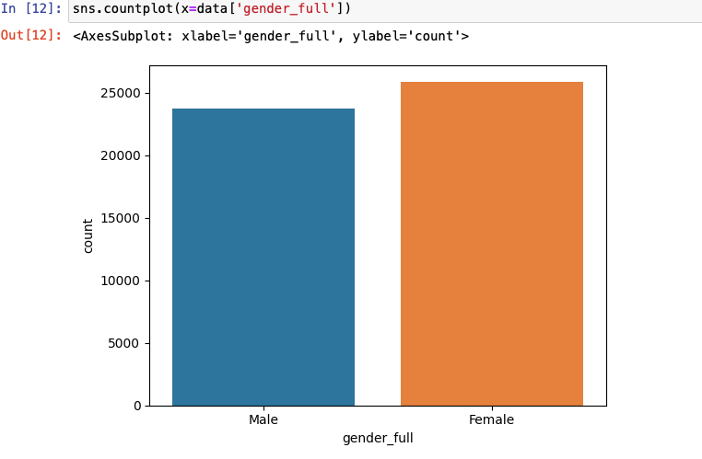
The Bars in the chart are representing the count of each category present in the business travel column.

2.
Bivariate analysis
Bivariate analysis is the simultaneous analysis of two variables. It explores the concept of the relationship between two variable.
Categorical v/s Numerical
import matplotlib.pyplot as plt
plt.figure(figsize=(15, 5))
sns.barplot(x=data['department_name'], y=data['length_of_service'])
plt.xticks(rotation='90')
Output:
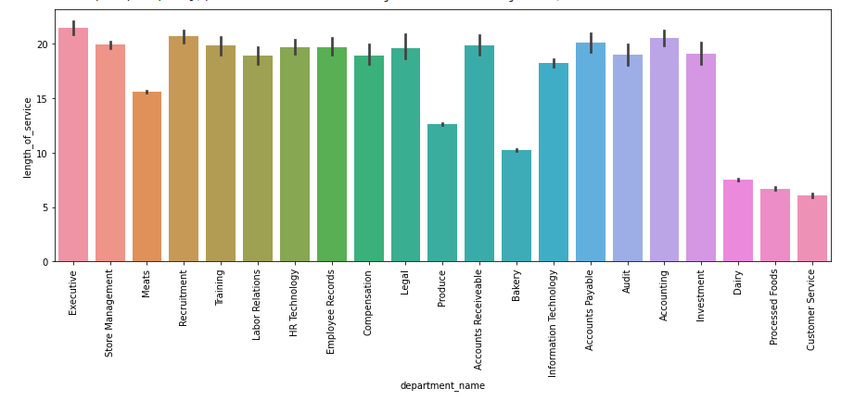 Here the Black horizontal line is indicating huge differences in the length of service among different departments.

Box Plot
A Box Plot is also known as a Box and Whisker Plot and it is a graphical tool used to understand the distribution of numerical data. It shows the median, quartiles and possible outliers in a simple visual form.
Interquartile Range (IQR)
The box in a box plot represents the Interquartile Range (IQR).
$$IQR=Q_{3}-Q_{1}$$

Machine Learning
Machine learning is a branch of Artificial Intelligence that focuses on developing models and algorithms that let computers learn from data without being explicitly programmed for every task. In simple words, ML teaches systems to think and understand like humans by learning from the data.
Machine Learning is mainly divided into three core types:
- Supervised Learning: Trains models on labeled data to predict or classify new, unseen data.
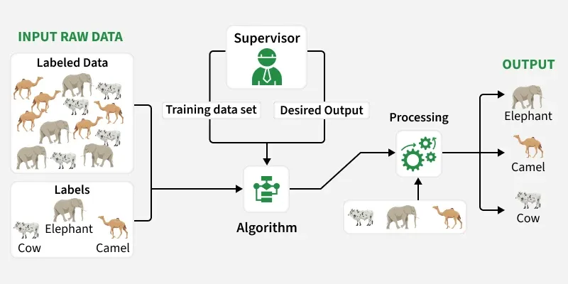
- Unsupervised Learning: Finds patterns or groups in unlabeled data, like clustering or dimensionality reduction.
- Reinforcement Learning: Learns through trial and error to maximize rewards, ideal for decision-making tasks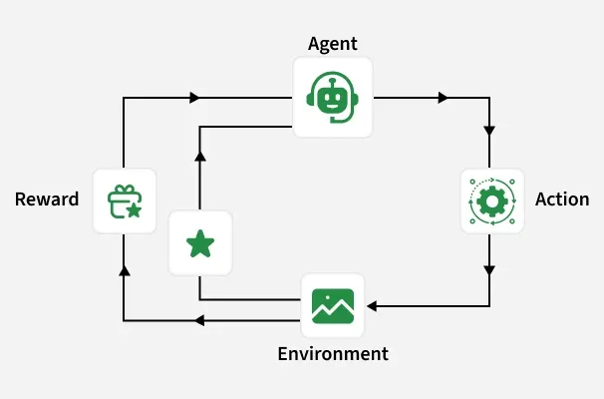
Supervised Learning
Supervised learning algorithms are generally categorized into two main types:
- Classification: where the goal is to predict discrete labels or categories
- Regression: where the aim is to predict continuous numerical values.

1. Linear Regression
This is one of the simplest ways to predict numbers using a straight line. It helps find the relationship between input and output.
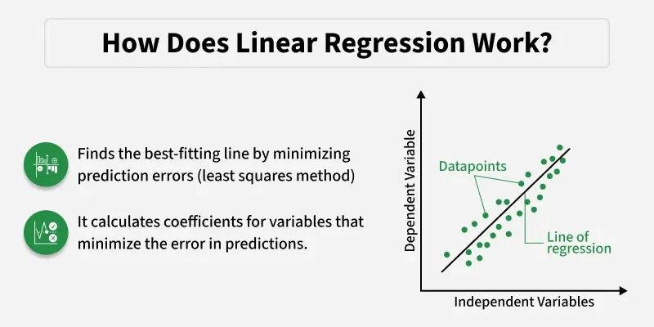

2. Logistic Regression
Used when the output is a "yes or no" type answer. It helps in predicting categories like pass/fail or spam/not spam.
- It is used for binary classification where the output can be one of two possible categories such as Yes/No, True/False or 0/1.

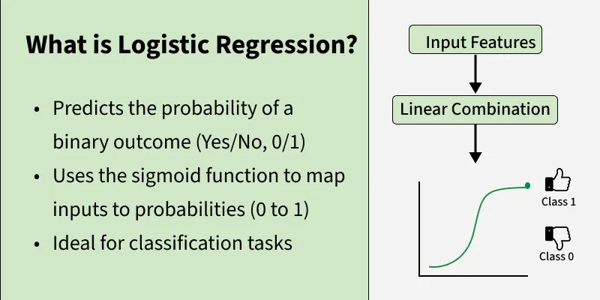

3. Decision Tree
A decision tree is a supervised learning algorithm used for both classification and regression tasks. It has a hierarchical tree structure which consists of a root node, branches, internal nodes and leaf nodes. It works like a flowchart that helps in making step by step decision, where:
- Internal nodes represent attribute tests
- Branches represent attribute values
- Leaf nodes represent final decisions or predictions.

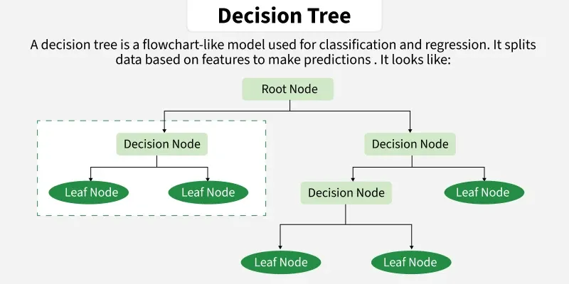

Support Vector Machine (SVM) Algorithm
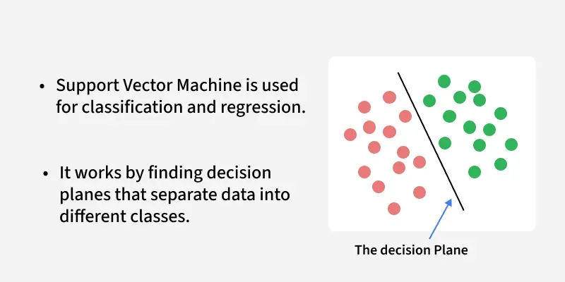

K-Nearest Neighbor(KNN) Algorithm
K-Nearest Neighbor (KNN) is a simple and widely used machine learning technique for classification and regression tasks. It works by identifying the K closest data points to a given input and making predictions based on the majority class or average value of those neighbors.

Module 3: Unsupervised learning
Unsupervised learning are again divided into three main categories based on their purpose:
- Clustering
- Association Rule Mining
- Dimensionality Reduction

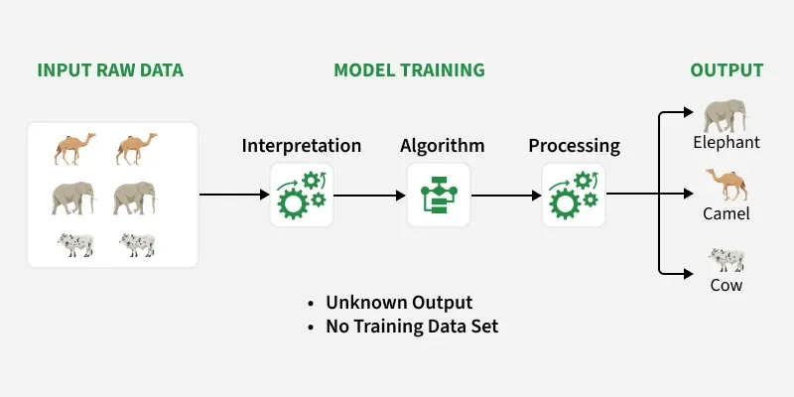
1. Clustering
Clustering algorithms group data points into clusters based on their similarities or differences.
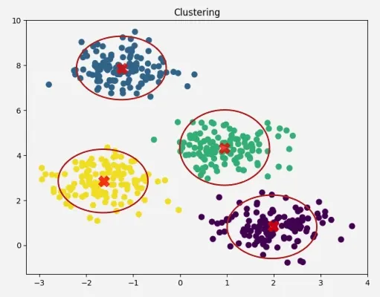
K means Clustering
K-Means Clustering groups similar data points into clusters without needing labeled data. It is used to uncover hidden patterns when the goal is to organize data based on similarity.
- Helps identify natural groupings in unlabeled datasets
- Works by grouping points based on distance to cluster centers
- Commonly used in customer segmentation, image compression, and pattern discovery.

2. Dimensionality Reduction

Dimensionality reduction is used to simplify datasets by reducing the number of features while retaining the most important information.

